- The UK current budget deficit overshot the Office for Budget Responsibility's projections in June, and it will be a tall order to get borrowing close to the OBR's full-year forecast. Growing evidence of structural weakness in the public finances adds to the list of reasons why the government is likely to need to implement sizeable tax rises at this autumn's Budget.
- July's flash S&P Global survey and Q2's retail sales pointed to a modest pace of activity growth. These series are noisy and likely suffer from some seasonality issues, so we interpret the outturns cautiously. But we see the outlook for activity as one of continued sluggish growth.
It has been a relatively busy week, with several official data releases and business surveys published. The public finances data saw the Office for National Statistics report that a surge in debt interest payments meant the government borrowed £20.7bn in June, which was well above both the Bloomberg consensus (£17.5bn) and what had been expected by the Office for Budget Responsibility (£17.1bn).
While overall borrowing over the first three months of the fiscal year was in line with the OBR's March forecast, developments in the current budget balance measure – which looks at borrowing to cover day-to-day spending and is the measure targeted for the Chancellor's main fiscal rule – look more concerning. Across the first three months of fiscal year 2025-2026, the current budget deficit was £44.5bn, £5bn higher than the OBR's forecast.
The OBR expects a steep drop in the current budget deficit in the latter part of FY2025-2026, which would leave the deficit around £35bn smaller than the previous year's outturn (Chart 1). This is based on the expectation of higher capital gains tax receipts and lower spending on debt interest payments and social benefits. That such a large improvement would be achieved towards the end of the year always looked optimistic. But with the deficit already overshooting expectations, absent favourable revisions, it looks likely that government borrowing will come in well above the OBR's full-year forecast.
Chart 1: A poor start to 2025-2026 makes the OBR's current budget forecast look even more optimistic
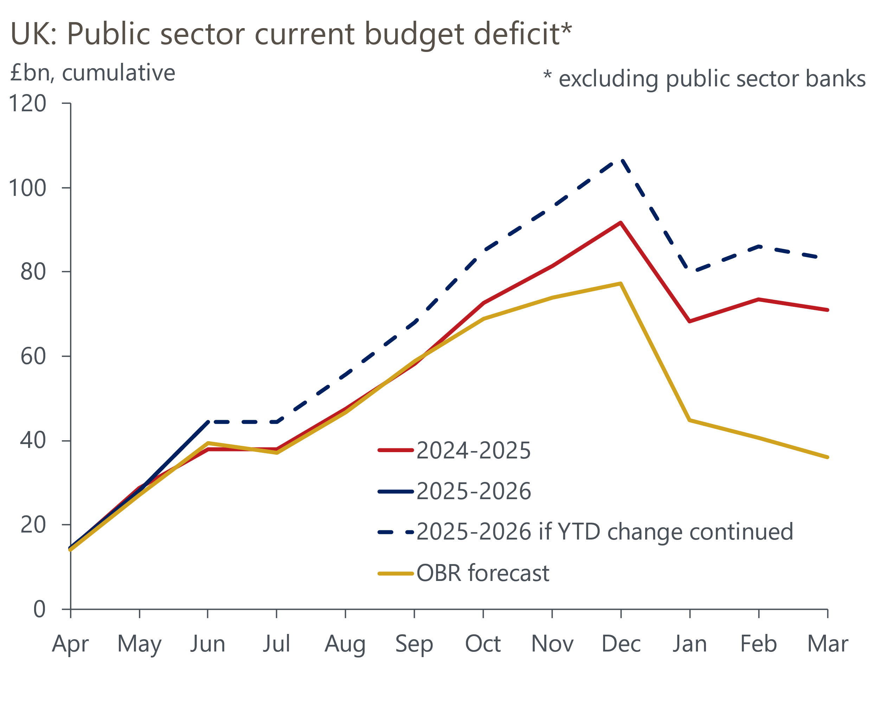
Sources: Oxford Economics, Haver Analytics & OBR

What matters for the fiscal rules is where the OBR thinks borrowing will be in five years' time. But if the OBR concludes that the recent current deficit overshoot is evidence of greater structural weakness in the public finances, it could assume that borrowing stays higher. There's four other factors that are likely to put pressure on the government to tighten policy further in the autumn.
From a starting point of just £9.9bn of headroom against the binding fiscal rule, the government's decision to reverse some of its welfare reforms and to restore winter fuel payments to some pensioners implies government spending will be about £5bn a year higher than was previously planned. Meanwhile, the rises in gilt yields and market expectations for Bank Rate since the Spring Statement imply that a further £4bn a year will need to be spent on debt interest payments over the medium term.
The OBR is likely to come under pressure to cut its optimistic potential growth forecasts, particularly in light of the surge in US trade policy uncertainty and the government rowing back on some of its more ambitious plans to boost productivity. Should the OBR bring their potential output forecast into line with the consensus, we estimate that the OBR's forecast for borrowing in the target year for the fiscal rules would rise by around £20bn.
The government is also likely to face pressure to increase spending on defence. Current plans imply the government will spend 2.6% of GDP on defence in the second half of this parliament. But this would mean a steep increase would be needed in the next parliament to achieve the new NATO target of 3.5% of GDP by 2035. A more plausible path to 3.5% would involve higher spending in the latter part of this parliament.
With the government having only recently concluded its spending review, and gilt market conditions not conducive to another loosening of the fiscal rules, sizeable tax rises are likely to prove unavoidable.
This week also saw the release of a raft of activity data, though these didn't provide much clarity on the economy's underlying momentum. The ONS reported that retail sales rose 0.9% month-on-month in June, but this only partially reversed the sharp fall seen in May and left sales growth at just 0.2% q/q in Q2 (Chart 2). There were signs of weak discretionary spending, but the volatility of recent outturns and continued issues with the ONS' seasonal adjustment of the data make it difficult to identify deeper trends.
Chart 2: Retail sales grew modestly in Q2, but this masked extreme sectoral volatility in the monthly data
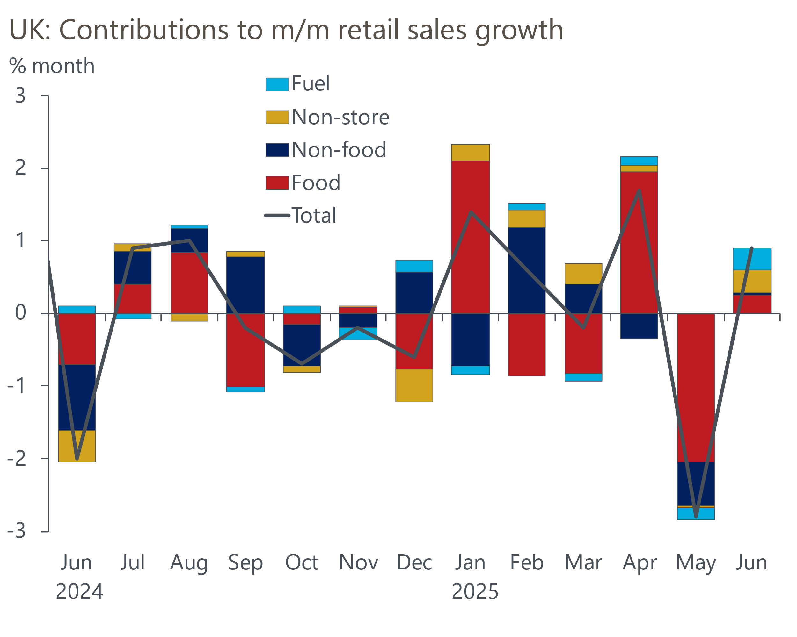
Source: Haver Analytics
Similarly, July's weaker flash S&P Global survey results shouldn't raise any eyebrows. The composite PMI slipped to 51.0 from 52.0 in June, signalling a more modest pace of expansion than in recent months. But the PMIs can be quite erratic month-to-month, and there has been a tendency for the survey's headline indices to cool in the second half of the year. On balance, the underlying picture for activity appears to be one of sluggish growth, and we think this is likely to continue in the near-term.

The week ahead
We expect June's Money & Credit release to show another rise in mortgage approvals. Secured lending activity picked up in May as distortions from the stamp duty threshold normalisation at the end of March showed signs of fading. We think a further easing in stamp-duty distortions likely supported stronger mortgage demand in June, so we forecast that mortgage approvals increased to 63,500, from 63,000 in May. Similarly, we expect May's recovery in gross secured lending to have continued, so we anticipate that net mortgage lending edged up to £2.2bn in June, from £2.1bn a month earlier.
Net unsecured lending has been very erratic in recent months, reflecting large swings in repayments. Alongside a small rise in gross lending, we think an unwinding of May's large rise in repayments is likely to have driven net lending higher in June. We project that net unsecured lending rose to £1.8bn, from £0.9bn in May.
July's flash manufacturing PMI rose to a six-month high of 48.2, as survey respondents reported that manufacturing production stabilised following eight consecutive months of contraction. With no clear pattern of revisions, we think the manufacturing survey's final results will be similar to this week's flash survey.
Table 1: Week ahead calendar
Date | Events | Period | Measure | Unit | Previous | Forecast
Jul 29 | Mortgage approvals | Jun | Level | 000s | 63.0 | 63.5
Jul 29 | Mortgage lending | Jun | Net lending | £bn | 2.1 | 2.2
Jul 29 | Consumer credit | Jun | Net lending | £bn | 0.9 | 1.8
Aug 1 | Nationwide house prices | Jul | m/m | % | -0.8 | 0.3
Aug 1 | Nationwide house prices | Jul | y/y | % | 2.1 | 2.1
Aug 1 | S&P Global manufacturing | Jul | PMI | % bal | 48.2 | 48.2
Source: Oxford Economics

Key forecasts
Table 2: UK forecast overview
(Annual percentage changes unless specified)
 | 2023 | 2024 | 2025 | 2026 | 2027 | 2028
GDP | 0.4 | 1.1 | 1.1 | 0.9 | 1.3 | 1.8
Private consumption | 0.5 | 0.6 | 1.1 | 1.1 | 1.2 | 1.8
Fixed investment | 0.3 | 1.5 | 1.8 | 0.8 | 1.6 | 2.0
Government consumption | 1.6 | 3.0 | 1.5 | 1.7 | 1.6 | 1.7
Exports of goods and services | -0.4 | -1.2 | 1.2 | 0.1 | 1.2 | 1.4
Imports of goods and services | -1.2 | 2.7 | 3.4 | -1.3 | 1.1 | 1.4
Industrial Production | -0.8 | -1.2 | 0.0 | -0.5 | 0.7 | 1.2
Consumer prices | 7.3 | 2.5 | 3.4 | 2.7 | 2.4 | 2.1
Unemployment rate (%) | 4.1 | 4.3 | 4.7 | 5.0 | 4.9 | 4.5
Current a/c balance (% of GDP) | -3.5 | -2.7 | -3.3 | -2.9 | -2.7 | -2.7
Government balance (% of GDP) | 5.2 | 5.1 | 4.3 | 3.6 | 3.0 | 2.7
Central bank policy rate (%, EOP) | 5.25 | 4.75 | 3.75 | 3.00 | 2.50 | 2.50
10yr govt. bond yield (%, EOP) | 3.54 | 4.57 | 4.55 | 4.04 | 3.47 | 3.35
Exchange rate (US$ per £, EOP) | 1.27 | 1.25 | 1.36 | 1.36 | 1.36 | 1.36
Exchange rate (euro per £, EOP) | 1.15 | 1.21 | 1.17 | 1.17 | 1.17 | 1.17
Source: Oxford Economics
Table 3: Quarterly forecasts for the UK
 | 2025 |  |  |  | 2026
 | Q1 | Q2 | Q3 | Q4 | Q1 | Q2 | Q3 | Q4
GDP (% year) | 1.3 | 0.9 | 1.1 | 1.2 | 0.7 | 0.8 | 0.9 | 1.0
CPI inflation (% year) | 2.8 | 3.5 | 3.8 | 3.5 | 3.3 | 2.5 | 2.5 | 2.5
Bank Rate (%, EOP) | 4.50 | 4.25 | 4.00 | 3.75 | 3.50 | 3.25 | 3.25 | 3.00
10yr gilt yield (%, EOP) | 4.70 | 4.48 | 4.60 | 4.55 | 4.48 | 4.35 | 4.20 | 4.04
US$ per £ (EOP) | 1.29 | 1.37 | 1.36 | 1.36 | 1.36 | 1.36 | 1.36 | 1.36
Euro per £ (EOP) | 1.20 | 1.17 | 1.17 | 1.17 | 1.17 | 1.17 | 1.17 | 1.17
Source: Oxford Economics

Latest Country Economic Forecast:
July 17, 2025

Recent publications

Data Insights
June rebound in retail sales hides a challenging backdrop
The PMIs started Q3 on a softer note
Tax rises are looking increasingly likely
Widening labour market cracks keep August rate cut on track
Small upside surprise for inflation won't derail an August rate cut

Research Briefings
Why interest rate cuts remain a blunt tool
BoE likely to slow QT to avoid adding to gilt market strains
How the sectoral mix of jobs is changing and what it means
MPC’s dovish hold boosts the chances of an August cut
MPC Preview – Divided committee to pause in June

Contacts

Oxford Economics' UK team
- Andrew Goodwin - Chief UK Economist - agoodwin@oxfordeconomics.com
- Edward Allenby - UK Economist - eallenby@oxfordeconomics.com

